***Это важно!***

***Это нужно!***

***Что мы вложим в ребёнка,***

***то потом и получим...***

[](http://ok.ru/dk?cmd=PopLayerPhoto&st.layer.cmd=PopLayerPhotoOuter&st.layer.type=FRIEND&st.layer.revNav=off&st.layer.limitedUi=false&st.layer.sphotoIds=803695381584;803695403600;803695408208;803695414352;803695419984;803695423312;803695428944&st.layer.fre=off&st.layer.showNav=on&st.layer.photoAlbumId=477720506704&st.layer.epm=off&st.layer.photoId=803695381584&st.layer.opl=off&st.layer.navStartPhotoId=803695381584&st.layer.sbd=off&st.cmd=userMain&st._aid=StatusLayer_openPhotoLayer)

[](http://ok.ru/dk?cmd=PopLayerPhoto&st.layer.cmd=PopLayerPhotoOuter&st.layer.type=FRIEND&st.layer.revNav=off&st.layer.limitedUi=false&st.layer.sphotoIds=803695381584;803695403600;803695408208;803695414352;803695419984;803695423312;803695428944&st.layer.fre=off&st.layer.showNav=on&st.layer.photoAlbumId=477720506704&st.layer.epm=off&st.layer.photoId=803695403600&st.layer.opl=off&st.layer.navStartPhotoId=803695403600&st.layer.sbd=off&st.cmd=userMain&st._aid=StatusLayer_openPhotoLayer)

[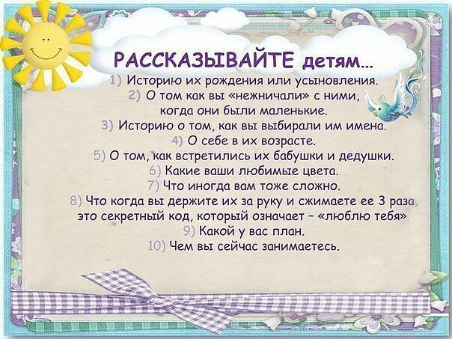](http://ok.ru/dk?cmd=PopLayerPhoto&st.layer.cmd=PopLayerPhotoOuter&st.layer.type=FRIEND&st.layer.revNav=off&st.layer.limitedUi=false&st.layer.sphotoIds=803695381584;803695403600;803695408208;803695414352;803695419984;803695423312;803695428944&st.layer.fre=off&st.layer.showNav=on&st.layer.photoAlbumId=477720506704&st.layer.epm=off&st.layer.photoId=803695408208&st.layer.opl=off&st.layer.navStartPhotoId=803695408208&st.layer.sbd=off&st.cmd=userMain&st._aid=StatusLayer_openPhotoLayer)

[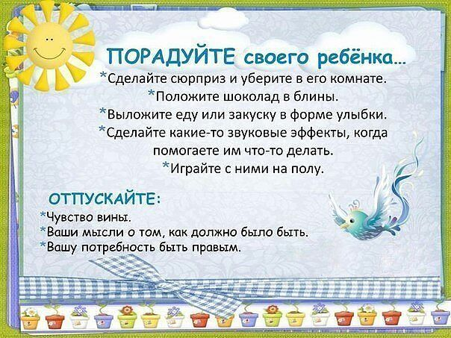](http://ok.ru/dk?cmd=PopLayerPhoto&st.layer.cmd=PopLayerPhotoOuter&st.layer.type=FRIEND&st.layer.revNav=off&st.layer.limitedUi=false&st.layer.sphotoIds=803695381584;803695403600;803695408208;803695414352;803695419984;803695423312;803695428944&st.layer.fre=off&st.layer.showNav=on&st.layer.photoAlbumId=477720506704&st.layer.epm=off&st.layer.photoId=803695414352&st.layer.opl=off&st.layer.navStartPhotoId=803695414352&st.layer.sbd=off&st.cmd=userMain&st._aid=StatusLayer_openPhotoLayer)

[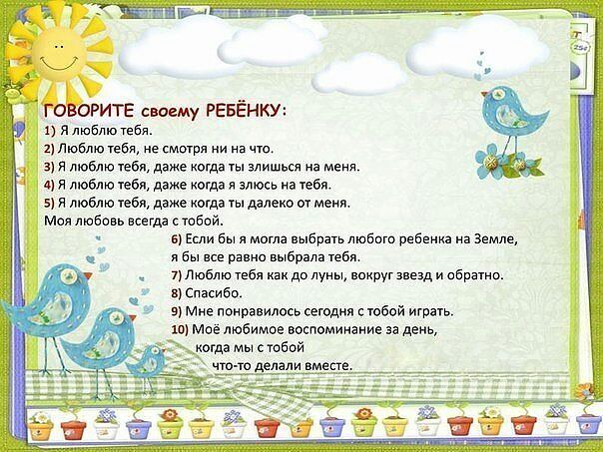](http://ok.ru/dk?cmd=PopLayerPhoto&st.layer.cmd=PopLayerPhotoOuter&st.layer.type=FRIEND&st.layer.revNav=off&st.layer.limitedUi=false&st.layer.sphotoIds=803695381584;803695403600;803695408208;803695414352;803695419984;803695423312;803695428944&st.layer.fre=off&st.layer.showNav=on&st.layer.photoAlbumId=477720506704&st.layer.epm=off&st.layer.photoId=803695419984&st.layer.opl=off&st.layer.navStartPhotoId=803695419984&st.layer.sbd=off&st.cmd=userMain&st._aid=StatusLayer_openPhotoLayer)

[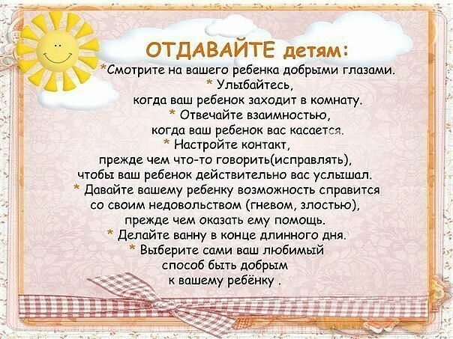](http://ok.ru/dk?cmd=PopLayerPhoto&st.layer.cmd=PopLayerPhotoOuter&st.layer.type=FRIEND&st.layer.revNav=off&st.layer.limitedUi=false&st.layer.sphotoIds=803695381584;803695403600;803695408208;803695414352;803695419984;803695423312;803695428944&st.layer.fre=off&st.layer.showNav=on&st.layer.photoAlbumId=477720506704&st.layer.epm=off&st.layer.photoId=803695423312&st.layer.opl=off&st.layer.navStartPhotoId=803695423312&st.layer.sbd=off&st.cmd=userMain&st._aid=StatusLayer_openPhotoLayer)

[](http://ok.ru/dk?cmd=PopLayerPhoto&st.layer.cmd=PopLayerPhotoOuter&st.layer.type=FRIEND&st.layer.revNav=off&st.layer.limitedUi=false&st.layer.sphotoIds=803695381584;803695403600;803695408208;803695414352;803695419984;803695423312;803695428944&st.layer.fre=off&st.layer.showNav=on&st.layer.photoAlbumId=477720506704&st.layer.epm=off&st.layer.photoId=803695428944&st.layer.opl=off&st.layer.navStartPhotoId=803695428944&st.layer.sbd=off&st.cmd=userMain&st._aid=StatusLayer_openPhotoLayer)